1. Project introduction
2. Overview
3. Project Information

* Project Name: Sample Facebook
* Project Code: SF
* Group Name: K13 Perfection
* Software Type: Web Application

1. Project team
2. Supervisor

|  |  |  |  |
| --- | --- | --- | --- |
| Full Name | Email | Phone Number | Title |
|  |  |  | Lecturer |

1. Team Member

|  |  |  |  |
| --- | --- | --- | --- |
| Full Name | Email | Phone Number | Title |
| Tran Vu Truong |  |  | Leader |
| Le Thi Ngoc |  |  | Member |
| Nguyen Huu Lam Phong |  |  | Member |
| Le Hoang Anh |  |  | Member |
| Tran Binh Minh |  |  | Member |

1. Product background

With the scientific and technological revolution 4.0, social networks are dominating information, entertainment and exchange channels not only of young people. Using social media brings many benefits.

We are living in a globalized world, "a flat world", an era of digital, science and technology develops like a storm, people make tireless efforts to invent new inventions. institutions, tools to serve, to meet the endless needs of mankind. In particular, the Internet in general and social networks in particular are extremely useful tools.

More and more people tend to do more exchanges on social networks.

1. Existing System
2. Face Book

Facebook (abbreviated as FB), a social network that was born later than some predecessors such as: Myspace, Yahoo!Blog,...but it has quickly become a giant social network, number one in the world, attract billions of participants, overwhelm the competitors. Just like that, it was possible to see its magic power, its utility as well as its influence on society.

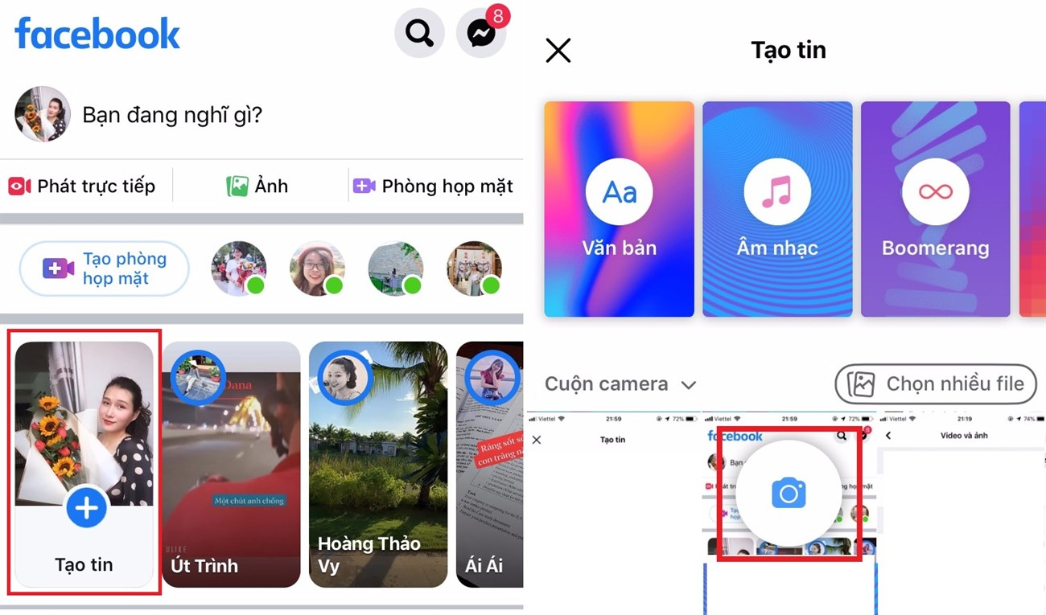

It is almost like a vivid diary recording emotions, impressions, feelings, sharing in daily life. FB is a utility, a dynamic social network that constantly gives young people interesting experiences and tools to make friends, exchange, talk and find information. Just having an account in FB, users can post on it content, photos, clips, etc., share with everyone, comment, like back, encourage their work. fake.

1. Bussiness Opportunity
2. Software Product Vision

Sample Facebook is a web application, it is a tool people will use to post, share any information they want to others.

People can come here to share information and exchange what they know about a topic posted by themselves or others.

1. Project Scope & Limitation
2. Major Features

FE-01: Users can post what they want

FE-02: User can comment on another post

FE-03: User can reply to comments

FE-04: User can delete the comments of us

FE-05: Users can search for a post they want

1. Limitation & Exclusion